Server/Client Communication
The key requirement for this project was to be able to remotely control the system. As a result, this inherently introduced a separation between the controlling software and the client interface. Therefore, to maintain reliable control over the system, a suitable communication method had to be devised between the two.

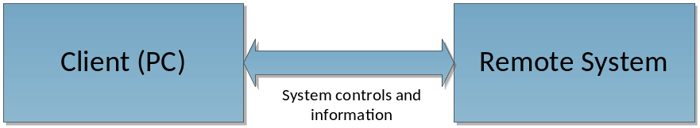
Figure 1. Block diagram of client-server communications

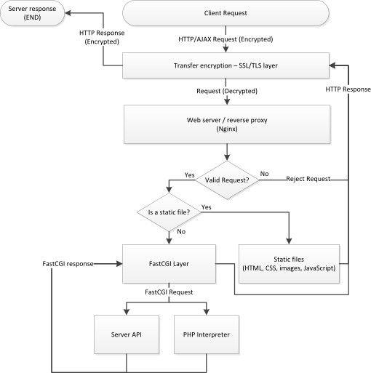
Figure 2. High level flow chart of a client request to server response (implemented)

To satisfy this requirement, the server software has been designed to interact with the client over the internet, completely through a standard web browser (Figure 2). No extra software should be required from the client. Reasons for this choice are outlined below.

Web communication technologies
Choosing a suitable communication method between the client and server was not trivial. It had to allow for anyone to remotely control the experiment, while imposing as little requirements from the user as possible. In this respect, the requirements for the communication method can be summarised as such:
- A widely available, highly accessible service should be used, to reach as many users as possible
- Communication between client and server should be fairly reliable, to maintain responsiveness of the remote interface
- Communication should be secured against access from unauthorised persons, to maintain the integrity of the system

To satisfy the first criteria, remote control via some form of internet access was the natural choice. Internet access is widely established and highly accessible, both globally and locally, where it can be (and is) used for a multitude of remote applications. One only needs to look as far as the UWA Telelabs project for such an example, having been successfully run since 1994. [REF]

Internet communications itself is complex, and there is more than one way to approach this issue of remote control. A number of internet protocols exist, where the protocol chosen is based on the needs of the application. Arguably most prevalent is the Hypertext Transfer Protocol (HTTP) used in conjunction with the Transmission Control Protocol (TCP) - to distribute web pages and related content across the internet. Other protocols exist, but are less widely used. Even custom protocols can be used, but that comes at the cost of having to build, test and maintain an extra component of software that likely has no benefit over pre-existing systems.

As a result, being able to control the system via a web page and standard web browser seemed the most logical choice, which was why it was used in the final design. Firstly, by designing the system to be controlled from a web page, the system becomes highly accessible, given that where internet access is present, the presence of a web browser is almost guaranteed. Nothing else from the client is required.

Secondly, setup and maintenance for the server is less involved, given that there is a wide range of pre-existing software made just for this purpose. Many features of the web browser can also be leveraged to the advantage of the system – for example, communications between the client and server can be quite easily secured using Transport Layer Security (TLS, previously known as Secure Sockets Layer or SSL).

Thirdly, reliability of the communications is better guaranteed by using such existing technology, which has been well tested and proven to work of its own accord. While internet access itself may not always be fully reliable, the use of such protocols and correct software design allows for a fair margin of robustness towards this issue. For example, TCP communications have error checking methods built-in to the protocol, to ensure the correct delivery of content. Similarly, HTTP has been designed with intermittent communications to the client in mind. [REF]
Server interface
Even when the choice was settled on using standard HTTP requests to remotely control the system, there were a number of methods available to actually implement this approach. After exploring the available options, the final system was implemented as a FastCGI process.

The server software had to be designed on the assumption that remote control would be intermittent. Thus, the server interface had to allow for sensor logging and actuator control, independent of the requests from clients. This meant that some portion of software had to continuously run to maintain this control, while another portion had to respond to web requests, and react appropriately.

Many web server technologies exist and common examples of this include the Apache HTTP Server, Lighttpd, Microsoft Internet Information Services (IIS), and more recently, nginx. All allow static files (e.g. HTML files) to be served easily, but serving dynamic content, such as access to the controls and sensors is much less trivial.

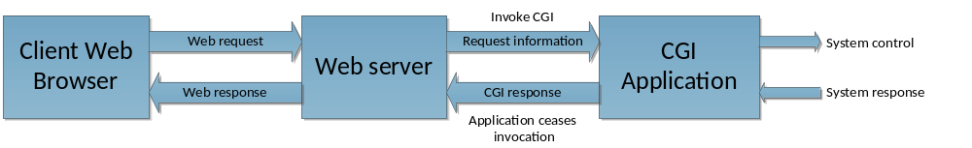
Figure 3. Block diagram of a request to a CGI application

Initially, a system known as ‘Common Gateway Interface’, or CGI was explored. CGI allows the web server to generate dynamic content by calling an external program. The external program is suitably designed to perform tasks based on the request. Upon completion of such tasks, it generates a response for the web server to forward to the client, and ceases execution.

CGI based software is only executed when a request is received, which makes continuous control and logging over the sensors and actuators unfeasible. This was why this approach was discarded and other options explored instead.

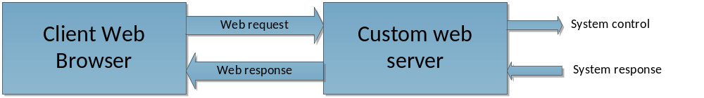
Figure 4. Block diagram of a custom web server

Up until a variation of CGI was found (FastCGI), the plan was to build a custom web server that used threading. In this manner, both the sensor/actuator control and the web interface would reside in the same process. By having both in the same process, continuous control is possible whilst waiting for web requests to be received.

This would have worked, and in fact operates similarly to the final solution, but it was not without drawbacks. By building a custom web server, more effort would have to be spent just to maintain low-level web functionalities, such as responding appropriately to a client request. Perhaps more importantly, features taken for granted from a standard web server would become increasingly difficult to support with a custom web server. For example, services like TLS encryption and PHP support would be near-impossible, or at least very difficult to add. In other words, it was deemed that this solution would be inflexible and not particularly maintainable into the future.

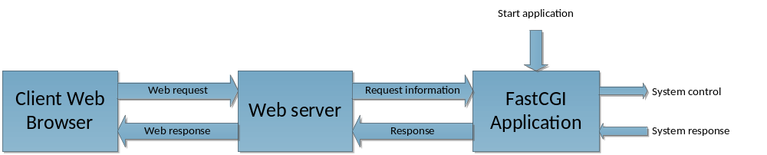
Figure 5. Block diagram of a FastCGI application

The final technology considered was that of FastCGI. As mentioned previously, it is a variant of CGI, in that it allows some software to respond to web requests. The key difference is that with FastCGI, the program is continuously run independent of any web requests. This overcomes the issues faced with either using CGI or a custom web server; continuous control can be achieved while also not having to worry about the low-level implementation details a web server.

Web server
Coupled with the FastCGI component was the web server that glued everything together. For this project, the nginx web server was chosen. Either Apache, nginx or any other well-established web server would have been fine for this project, as long as it supported the FastCGI protocol. nginx was chosen because it had built-in support for FastCGI, and also because it was lightweight and performance-oriented [REF].

Referring to Figure 1, nginx is responsible for negotiating and maintaining the encryption layer with the client. It is also responsible for serving static content to the client, such as the GUI HTML/CSS/JavaScript files and the system logs. Quite importantly, nginx acts as the FastCGI ‘host’. It receives a client request, and translates it as appropriate for FastCGI. The request is then forwarded to the appropriate application that responds back to the FastCGI layer. This response is then translated back to an appropriate HTTP response, which nginx then serves to the client.

The FastCGI layer that nginx controls is what allows multiple applications to interface with web requests, and is exemplified by how PHP requests are processed in another FastCGI process.

[BLAH BLAH BLAH]

Server API
To allow the client to make requests from the server, an Application Programming interface (API) had to be designed. Quite simply, the API allows the user to make a request to some specific URL, where the response to querying that URL will be in some predetermined format that the client can use.

In the case of the server API designed, requests are formatted as such:
https://host/api/module?key₁=value₁&key₂=value₂...&key_{n}=value_{n}

As exemplified, the API consists of modules that can accept a certain number of arguments (specified as key-value pairs), depending on what that module does. For example, to query the API about basic information (running state, whether the user is logged in etc), the following query would be used:

https://host/api/identify

The server would then respond with this information. In this case, the identify module does not require any arguments for it to function. However, it can accept two optional arguments, ‘sensors’ and ‘actuators’, which makes it give extra information on the available sensors and actuators present. This makes the following queries possible:

https://host/api/identify?sensors=1
https://host/api/identify?actuators=1
https://host/api/identify?sensors=1&actuators=1

This gives information on the sensors, actuators, or both, respectively. In a similar manner, there are modules to query and control the sensors and actuators, as well as modules that handle user logins and experiment control.

This form of an API was chosen because it is simple to use, and extremely easy to debug, given that these requests can just be entered into any web browser to see the result. The request remains fairly human readable, which was another benefit when debugging the server code.

Keeping the API format simple also made it easier to write the code that parsed these requests. All the API parsing and response logic lies in fastcgi.c. On the server side, modules are handled by different ‘module handlers’. The framework in fastcgi.c parses a client request and delegates it to the relevant module handler. Once the module handler has sufficiently processed the request, it creates a response, using functions provided by fastcgi.c to do so.

In this manner, the functions defined in fastcgi.c forms the bridge between web requests and the control logic that continuously runs.

[INSERT FLOW CHART OF FASTCGI.C]

AJAX
/server API
/FastCGI
http/s, cookies

